**Worksheet-3.2**

**Student Name:- Pushpraj Roy UID:- 20BCS9866**

**Branch:- BE- CSE Section/Group:- WM_617 “A”**

**Subjetct Code:- 20CSP-321 Semester:- 5th**

**Subject Name:- PBLJ Lab**

1. **Aim/ Overview of the practical:-**

Create a Servlet/ application with a facility to print any message on web browser.

1. **S/W Requirements:-**

* Eclipse
* VS Code

1. **Algorithm/ PsuedoCode:**

* Create a index.jsp file in a webapp directory.
* Create a package named as fun and create a java file named as

functions.java .

* Functions.java file contains the logic for checking the validation in

the form of submitting.

* At Last start the server and display the output on the web browser.
* EXIT

1. **Code :-**

**Index.jsp**

<%@ page language="java" contentType="text/html; charset=ISO-8859-1"

pageEncoding="ISO-8859-1"%>

<!DOCTYPE html>

<html>

<head>

<meta charset="ISO-8859-1">

<title>Insert title here</title>

<style>

h1{

margin: auto;

width: 60%;

padding-left: 100px;

}

body {

background:orange;

color: white;

}

.fall {

background: grey;

color: white;

border: 2px solid blue;

width: 45%;

margin:auto;

}

.input-group{

position: relative;

margin: 23px;

left: 175px;

}

button{

position: relative;

left: 35%

}

button:hover{

cursor:pointer;

background: black;

color: white;

}

h3{

margin: auto;

width: 40%;

padding: 5px;

}

</style>

</head>

<body>

DEPARTMENT OF

COMPUTER SCIENCE & ENGINEERING

<h1>Welcome the AP Auctions, Please Enter the Bid</h1>

<form class="fall" name="register_form"

action="<%=request.getContextPath()%>/functions" method="post" >

<div class="input-group mb-2">

<input type="text"name="name" id="name"

onkeypress="return /[0-9a-zA-Z]/i.test(event.key)" class="form-control input_user"

required="required"

placeholder="Item

ID">

</div>

<p class="error" id="name_id"></p>

<div class="input-group mb-2">

<div class="input-group-append">

<span class="input-group-text"><i class="fas fauser"></i></span>

</div>

<input type="text" name="branch" id="branch"

onkeypress="return /[0-9a-zA-Z]/i.test(event.key)" class="form-control input_user"

required="required"

placeholder="Item

Name">

</div>

<p class="error" id="branch_id"></p>

<div class="input-group mb-2">

<div class="input-group-append">

<span class="input-group-text"><i class="fas fauser"></i></span>

</div>

<input type="text" name="course" id="course"

onkeypress="return /[0-9a-zA-Z]/i.test(event.key)" class="form-control input_user"

required="required"

placeholder="Your

Name">

</div>

<p class="error" id="course_id"></p>

<div class="input-group mb-2">

<div class="input-group-append">

<span class="input-group-text"><i class="fas

fa-user"></i></span>

</div>

<input type="email" name="email" id="email"onkeypress="return

/[0-9a-zA-Z.@_]/i.test(event.key)" class="form-control input_user"

required="required"

placeholder="Email">

</div>

<p class="error" id="email_id"></p>

<div class="input-group mb-2">

<div class="input-group-append">

DEPARTMENT OF

COMPUTER SCIENCE & ENGINEERING

<span class="input-group-text"><i class="fas

fa-user"></i></span>

</div>

<input type="number" id="number"

onKeyPress="if(this.value.length==10) return false;" name="number" class="formcontrol input_user" required="required"

placeholder="Amount

Bid">

</div>

<p class="error"

id="number_id"></p>

<button type="submit" onclick=hide()>Submit Bid</button>

</form>

<script>

document.getElementById("name").addEventListener("keypress", myname);

document.getElementById("name").addEventListener("mouseover", myname);

function myname() {

var name= document.register_form.name.value;

var paragraph = document.getElementById("name_id");

if(name.length==0){

paragraph.textContent="Please enter your Id !!";

document.register_form.name.focus();

}

if(name.length>5 && name.length!=0){

paragraph.textContent="\ID should not be greater than 5

character !!!";

document.register_form.name.focus();

}

if(name.length<5){

paragraph.textContent="";

}

}

document.getElementById("email").addEventListener("keypress", myemail);

document.getElementById("email").addEventListener("mouseover", myemail);

function myemail() {

var email= document.register_form.email.value;

var paragraph = document.getElementById("email_id");

if(email.length==0){

paragraph.textContent="Please enter your email !!";

document.register_form.email.focus();

}

else if(!(/^\w+([\.-]?\w+)*@\w+([\.-

]?\w+)*(\.\w{2,3})+$/.test(email))){

paragraph.textContent="Enter valid email !!!";

document.register_form.email.focus();

}

else{

paragraph.textContent="";

}

}

DEPARTMENT OF

COMPUTER SCIENCE & ENGINEERING

document.getElementById("branch").addEventListener("keypress",

mybranch);

document.getElementById("branch").addEventListener("mouseover",

mybranch);

function mybranch() {

var branch= document.register_form.branch.value;

var paragraph = document.getElementById("branch_id");

if(branch.length<1){

paragraph.textContent="Please enter your Item Name !!";

document.register_form.branch.focus();

}

else{

paragraph.textContent="";

}

}

document.getElementById("course").addEventListener("keypress",

mycourse);

document.getElementById("course").addEventListener("mouseover",

mycourse);

function mycourse() {

var course= document.register_form.course.value;

var paragraph = document.getElementById("course_id");

if(course.length<1){

paragraph.textContent="Please enter your Name !!";

document.register_form.course.focus();

}

else{

paragraph.textContent="";

}

}

document.getElementById("number").addEventListener("keypress",

mynumber);

document.getElementById("number").addEventListener("mouseover",

mynumber);

function mynumber() {

var number= document.register_form.number.value;

var paragraph = document.getElementById("number_id");

if(number.length==0){

paragraph.textContent="Please enter your Amount Bid !!";

document.register_form.email.focus();

}

else if(!(/^[6-9]\d{9}$/.test(number))){

paragraph.textContent="Enter valid Amount Bid !!!";

document.register_form.number.focus();

}

else{

paragraph.textContent="";

}

}

DEPARTMENT OF

COMPUTER SCIENCE & ENGINEERING

</script>

<h3>Bid Submitted</h3>

<h3>Your bid is now active. if your bid is successful, you will be notified

within 24HRS</h3>

<h3> Item id: <%=request.getAttribute("ans") %></h3> <br>

<h3> Item Name: <%=request.getAttribute("ans1") %></h3> <br/>

<h3> Your Name <%=request.getAttribute("ans2") %></h3><br/>

<h3> Email:<%=request.getAttribute("ans3") %></h3><br/>

<h3> Your Amount: <%=request.getAttribute("ans4") %></h3><br/>

</body>

</html>

**Functions.java**

package fun;

import java.util.*;

import java.io.IOException;

import java.io.PrintWriter;

import javax.servlet.ServletException;

import javax.servlet.annotation.WebServlet;

import javax.servlet.http.HttpServlet;

import javax.servlet.http.HttpServletRequest;

import javax.servlet.http.HttpServletResponse;

/**

* Servlet implementation class functions

*/

@WebServlet(name="functions",urlPatterns={"/functions"})

DEPARTMENT OF

COMPUTER SCIENCE & ENGINEERING

public class functions extends HttpServlet {

protected void doPost(HttpServletRequest request,

HttpServletResponse response) throws ServletException,

IOException {

String a=request.getParameter("name");

String b=request.getParameter("branch");

String c=request.getParameter("course");

String d=request.getParameter("email");

String e=request.getParameter("number");

try {

String ans=a;

String ans1=b;

String ans2=c;

String ans3=d;

String ans4=e;

request.setAttribute("ans",ans);

request.setAttribute("ans1",ans1);

request.setAttribute("ans2",ans2);

request.setAttribute("ans3",ans3);

request.setAttribute("ans4",ans4);

DEPARTMENT OF

COMPUTER SCIENCE & ENGINEERING

request.getRequestDispatcher("index.jsp").forward(request,re

sponse);

}catch(Exception e1) {

System.out.println(e1);

}

}

}

1. **Result/Output/Writing Summary:-**

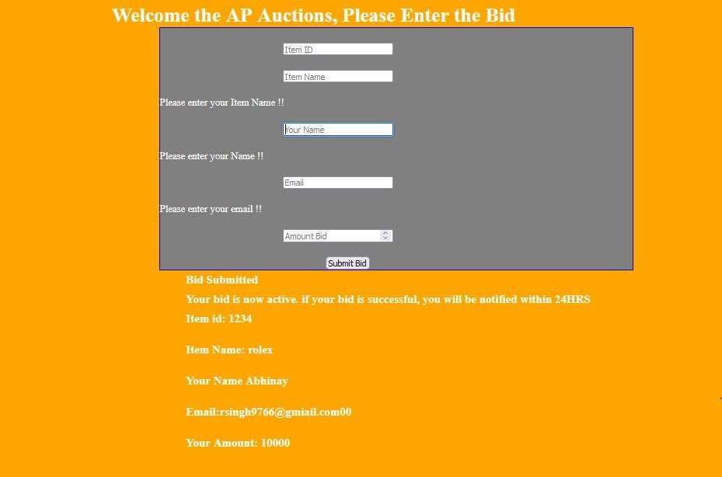

1. **Learning outcomes (What I have learnt):**

* Learn About the servlet
* Learn about jsp and dynamic web project
* Learn about the tomcat server and its integrations with the java.